Article of the Week #4
Directions:
1. Mark your confusion.
2. Show evidence of a close reading. Mark up the text with questions and/or comments.
3. Fill out the T-Chart for the facts and why it matters.

comments

Jimmy Graham has aided Eric Ebron's development in Detroit Lions' offensive system
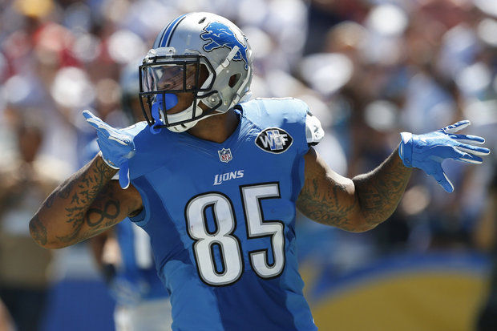
Eric Ebron gets advice from Seattle Seahawks counterpart Jimmy Graham as the Detroit Lions young tight end navigates the early stages of his professional career. (AP Photo)
Print Email
By Justin Rogers | jrogers@mlive.com
Follow on Twitter
on October 02, 2015 at 7:01 AM, updated October 02, 2015 at 7:12 AM
ALLEN PARK -- Eric Ebron was drafted to be the Detroit Lions' version of Jimmy Graham. On Monday, the two athletic tight ends will share the same field when the Lions (0-3) travel to Seattle to square off the with Seahawks (1-2) in primetime.
Graham, in his first season with Seattle after five productive years with the New Orleans Saints, has actually been serving as a mentor to Ebron as he navigates the early stages of his professional career.
"I talk to Jimmy," Ebron said. "He helps me out with this system a lot."
The offensive scheme Detroit runs under coordinator Joe Lombardi is grounded in the New Orleans' system where Graham blossomed into one of the league's best tight ends. Before being traded to Seattle, he averaged 89 catches, 1,099 receiving yards and 12 touchdowns the past four seasons.
The pair got connected through Butch Davis, who coached both Ebron (North Carolina) and Graham (Miami) in college.
Graham, who had a similarly slow start to his NFL career, preaches patience to Ebron.
"The situations I get put him, he's been there, done that," Ebron said. "He knows how to handle himself in those situations. I'm still learning. This is only my second year in the league and I'm 22. Everything I have to do, everything I'm going through, I'll learn from it and get better at it."
And while Ebron may not be able to match Graham's dramatic, second-year statistical leap, the Detroit Lions' budding young talent is making clear strides with his production. Through three games, he's hauled in 13 passes for 157 yards and two touchdowns, putting him on pace to more than triple his rookie numbers.
Players often keep personal goals to themselves, but the ever-confident Ebron shared one of his with reporters on Wednesday.
"I'll just be honest, one of my goals is to score a touchdown each game," Ebron said. "It's one of the hardest things to do in the NFL. It's hard to score a touchdown period in the National Football League."
The Lions would likely be elated if he managed half that mark in 2015.
But while he's becoming a more reliable option in the Lions' passing attack, some other aspects of Ebron's game remain a more obvious work in progress.
With Brandon Pettigrew sidelined with a hamstring injury the past two weeks, Ebron has seen his playing time sharply increase. He's played at least 70 snaps the past two games, with a particularly notable rise in blocking assignments.
He openly admits he struggled at times with those assignments in the team's loss to the Denver Broncos last Sunday.
"Man, that's rough," he said. "I definitely learned from it. Those are two elite pass rushers (Von Miller and DeMarcus Ware). We knew that coming in. I tried my best to slow them down, but they got me. That's just what they do. That's not what I do, but I've got to do it."
As he continues to improve, Ebron is studying the elite at his position. That starts with Graham, because of the similarities in their playing style, but Ebron is also watching what Rob Gronkowski has been doing in New England.
"I do pay a lot of attention to Rob Gronkowski," Ebron said. "He's dominant and everybody knows that. And I do pay attention to Jimmy because he's elite. He's world-class."
As the No. 10 selection in the 2014 draft, the vision remains for Ebron to one day join the same conversation.

