Article of the Week #2 – Social Media & Cyberbullying Articles
Directions:
1. Mark your confusion.
2. Show evidence of a close reading. Mark up the text with questions and/or comments.
3. Fill out the T-Chart for the facts and why it matters.

Should kids be on Facebook?
Kids under 13 aren't allowed on Facebook. But the site may soon lower its age limit. Supporters say Facebook is a safe place for kids to connect with friends--if their parents are involved. Many note that lots of preteens are already on the site because they lied about their ages. But others say preteens don't understand the risks of sharing private information online. Here's what two of our readers think.
JASON MARCHESE - Connecticut
Yes. Facebook should let kids under 13 have a page. I have one, and it's really fun. There are games, and you can talk to friends and video chat with them. You just need to make sure your parents know that you have a page so they can check it and make sure it's safe.
MADDIE GREENBERG- New York
No. Kids younger than 13 shouldn't be on Facebook. It can lead to cyberbullying. The site makes it even easier for kids to be mean to each other. Also, strangers could get personal information about you, such as your address, and that could put you and your family in danger.
The Consumer Union, which publishes Consumer Reports, conducted a survey that found that 7.5 million Facebook users are under the required 13 years of age. In fact, more than 5 million of those young people are under 10 years old. Only about 18 percent of parents with children under age 10 who use Facebook say that they have "friended" their children in order to monitor the accounts.
The survey also found that about 1 million young Facebook users say they have been cyberbullied on Facebook in the past year. This included forms of harassment and threats.
Source Citation (MLA 7th Edition)
"Should kids be on Facebook?" Scholastic News/Weekly Reader Edition 4 5 Nov. 2012: 7+. Junior
Edition. Web. 1 Feb. 2013. http://go.galegroup.com/ps/i.do?id=GALE%7CA309792984&v= 2.1&u=lom_accessmich&it=r&p=STOJ&sw=w

Facebook use said source of envy, jealousy
Source: UPI NewsTrack. (Jan. 23, 2013):
BERLIN, Jan. 23 (UPI) -- Spending time on Facebook can be an unhappy experience, German researchers say, as seeing pictures and posts of other users' can lead to envy and jealousy.
The study, titled "Envy on Facebook: A hidden threat to users' life satisfaction?" was conducted at Humboldt University in Berlin and Darmstadt's Technical University, the Los Angeles Times reported Wednesday.
In a survey of 357 people -- mostly German university students -- about a third said they felt worse after visiting the social networking site and their "general dissatisfaction" with life increased.
Holiday photos are the biggest cause of resentment, causing more than half of all feelings of envy, the researchers found.
While Facebook allows users to keep up to date with a great number of people, it also produces a "basis for social comparison and envy on an unprecedented scale," the study said.
"We were surprised by how many people have a negative experience from Facebook with envy leaving them feeling lonely, frustrated or angry," researcher Hanna Krasnova from Humboldt University said.
Source Citation (MLA 7th Edition)
"Facebook use said source of envy, jealousy." UPI NewsTrack 23 Jan. 2013. Junior Edition. Web. 1 Feb.
2013.http://go.galegroup.com/ps/i.do?id=GALE%7CA316078736&v=2.1&u=lom_accessmich&it=r&p=STOJ&sw=w

Be cyber safe (and smart): think twice - or maybe even three times - before you post that
Author(s): Valerie Van Kooten
Source: Boys' Life. 102.6 (June 2012): p30.
Josh is 16 and starting to think about college. He hopes to get a job this year to add to his college fund. When Josh met with his school guidance counselor to talk about classes he'd need for college, he was amazed to hear that the first thing he should do is take a look at his Facebook account.
"Hiring personnel and colleges are now taking a look at social networking sites," his guidance counselor told him. "They want to see what kinds of things are posted about the person they might hire or might accept to their school."
Many colleges do routine Internet searches on potential students.
When Josh did a search on himself by typing his name into a search engine, he was shocked by what he found. One of his Facebook friends had posted a picture of Josh on his own page--a picture Josh had never seen--that showed him acting silly at a party and making strange faces. Anyone looking at it could think that Josh had been drinking.
And on his own FB page, Josh had some bad language that he didn't want college recruiters seeing. On YouTube, there was a video of Josh and some kids pulling a stupid prank on their town square that was illegal.
Keeping Clean
Here are some pointers for keeping your online presence clean:
* Remember that nothing really ever goes away. Think twice (or three times) about what you post (and what you do that might get posted). It'll still be floating around in cyberspace years and years later.
* Think about how many "friends" you need. Every time you add a friend on a social network site, you're giving him or her access to your private info.
"Do you really need 750 friends?" asks Michael Ferjak, senior cybercrime investigator with the Iowa attorney general's office. "You may keep your page clean, but your friends could be posting things about you on their pages."
* Realize that it's not private. A lot of people think that only their friends can see their page, but that isn't true. It's easy to get around the privacy settings and view anything on a personal page.
Staying Safe
It's important to be smart online--and it's also important to be safe.
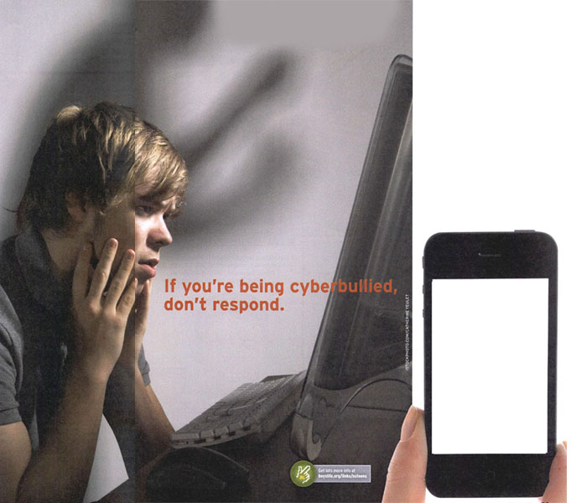
Even if you're careful not to post photos that show where you go to school or what town you live in, stalkers and predators can pick up that information using exifdata (exchangeable image file).
What's exifdata? Details that can be revealed through bits of information embedded in images taken with smartphones and some digital cameras and then shared on public websites. This data often includes the times, dates and geographical coordinates (latitude and longitude) where images are taken.
Here's what the Federal Bureau of Investigation's Cyber Alerts website says: When photos using that kind of data are posted, they can tell a lot about a person's daily activities. A predator using the geographical coordinates embedded in the photo can figure out exactly what malls you like to hang out at, where your school is and who your friends are.
Once this info is posted online, you lose control of it. How much do you really want to share?
If you're posting photos from a mobile phone, the FBI suggests checking the "options" or "settings" on your phone (and any other "apps" you've downloaded) to see if they are sharing location information. For many phones, sharing the information is the default setting, and you'll have to change that if you don't want your info shared.
For many phones, you'll have to go to Settings--General--Location Services and then check "Do not share" or something similar.
Being Nice
You're being smart and safe online--also make sure that you're being nice. Cyberbullying is not only unkind, it can also be illegal.
How do you deal with it? Here are some tips from boyslife.org/links/ connectsafely, a website especially for teens:
IF YOU'RE THE CYBERBULLY
* Get out of a group mentality. Sometimes people do things in a group that they wouldn't do alone. Look at your group of friends. Are they bullying someone? Are you part of it? Can you help stop it?
* Put yourself in the other person's shoes. How would you feel if this were being said about you or done to you?
* Realize there are consequences. Nothing is anonymous. Things can be tracked online and traced back to you. Almost every state has civil laws for cyberbullying, which means you and your family can be sued if you're the bully--sometimes for large amounts of money.
IF YOU'RE BEING CYBERBULLIED
* Don't respond. Usually the bully is trying to get a reaction from you. If you don't respond, he or she will move on. Although it's hard to do, experts say to leave your online world for a while. Don't log onto websites or blogs that are talking about you. Turn off your cell phone. Check your privacy settings and block the bully.
* Use the reporting tools. Often sites have a place to report abuse. If you forward to them what you're receiving, they might shut down the bully's posts.
* Preserve the evidence. Don't delete what you've received until an adult has decided what to do with it.
* Don't retaliate. It's hard not to fight back, but it's better not to make it worse and start a new cycle of bullying.
* Talk to a trusted adult. Afraid to talk to someone about this because you'll seem weak or you think your parents will take your computer away? Do it anyway. Talk to someone who can help.
* Be a friend. Often someone who is being bullied can't think clearly enough to report it. Be a friend and report it for them.
Source Citation (MLA 7th Edition)
Van Kooten, Valerie. "Be cyber safe (and smart): think twice - or maybe even three times - before you
post that." Boys' Life June 2012: 30+. Junior Edition. Web. 1 Feb. 2013. http://go.galegroup.com/ps/i.do?id=GALE%7CA291352913&v=2.1&u=lom_accessmich&it=r&p=STOJ&sw=w

