Article of the Week #3
Directions:
1. Mark your confusion.
2. Show evidence of a close reading. Mark up the text with questions and/or comments.
3. Fill out the T-Chart for the facts and why it matters.
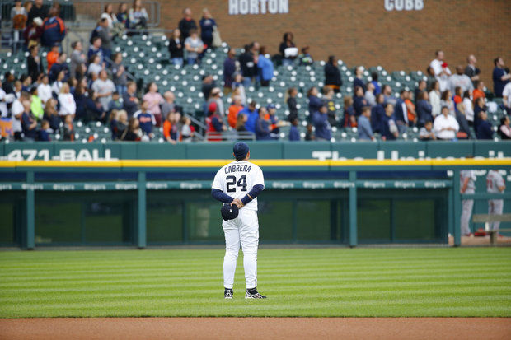
Miguel Cabrera is hitting .337 for the season and has a great chance to win the American League batting title. (AP File Photo)
5 things to watch: Can Detroit Tigers avoid cellar? will Miguel Cabrera win batting title?By Chris Iott | ciott@mlive.com
Follow on Twitter
on September 28, 2015 at 6:02 AM, updated September 28, 2015 at 6:09 AM
DETROIT -- Here are five things to watch this week regarding the Detroit Tigers:
Can the Tigers avoid finishing in last place in the Central Division?
When the Tigers wrapped up their four-game series with the Chicago White Sox last week, they trailed the White Sox by just a half-game in the division standings. After the Tigers dropped two of three this weekend to the Twins, that same half-game gap remained. Will the Tigers play well enough during a season-ending six-game road trip to avoid finishing in last place in the division for the first time since 2008, when they finished with just 74 victories? It could very well come down to a (likely) season-ending three-game series in Chicago between the Tigers and White Sox. The White Sox are off Monday, so the Tigers could pull into a fourth-place tie with them with a win over the Texas Rangers.
Will outfielder J.D. Martinez hit 40 home runs, knock in 100 runs?
Martinez has 37 home runs and 98 RBIs with six games remaining. (It could be seven games if the Tigers are forced to make up their recently rained-out game in Cleveland.) Those are career highs for Martinez, who hit 23 and drove in 76 runs for the Tigers last season. Can Martinez get hot on the road and hit enough home runs to reach the 40-home run plateau? Will he reach 100 RBIs? Globe Life Park in Arlington and U.S. Cellular Field are certainly hitter friendly enough for Martinez, who has power to all fields like few other players in the majors.
Will Miguel Cabrera win the American League batting title?
Cabrera has been slumping at the plate a bit and has missed a few games for various reasons. But he has 498 plate appearances, which leaves him one short of qualifying for the batting title if the Tigers play 161 games and three short if they play 162. He clearly will get enough plate appearances. But will he hit well enough to hold off guys like Xander Bogaerts, Jose Altuve and Michael Brantley? Cabrera is hitting .337. Bogaerts is second at .324. Cabrera has some breathing room. If he went 0 for 18 from this point forward, he would finish at .323.
How will the bullpen fare during the final week of the season?
The Tigers recently sent closer Bruce Rondon home due to a lack of effort. They have been very careful about using Alex Wilson based on his heavy workload this season. Buck Farmer only just recently came off the disabled list. The Tigers certainly have plenty of bodies in the bullpen, thanks to expanded rosters in September. But it has been a long season for a bullpen that has had a rough go of it. Will the Tigers try to limit anyone else's workload during the final road trip of the season?
Will Justin Verlander and Daniel Norris finish strong?
Verlander has been pitching very well for some time and has given the Tigers and their fans hope that he could be the ace of the staff again in 2016. Norris has pitched extremely well in two outings since returning from the disabled list. (His line in those two outings: 8.2IP, 1H, 1R, 1ER, 0BB, 8SO.) General manager Al Avila has plenty of work to do in the offseason when it comes to the pitching staff, but Verlander and Norris might help give Tigers fans some hope that next season might not look like this one.
-- Download the Detroit Tigers on MLive app for iPhone andAndroid.
-- Like MLive's Detroit Tigers Facebook page.

